Project Design Phase-II
Technology Stack (Architecture & Stack)

Date | 06 October 2026
Team ID | SWTID-2026-9105
Project Name | Implement Client Script & UI Policy (Incident)
Maximum Marks | 4 Marks

Technical Architecture:
The technical architecture describes how ServiceNow Incident forms, UI Policies, UI Policy Actions, and Client Scripts work together to enforce field behavior, automate updates, validate submissions, and control list editing.
Project Architecture: ServiceNow Incident Client-Side Controls
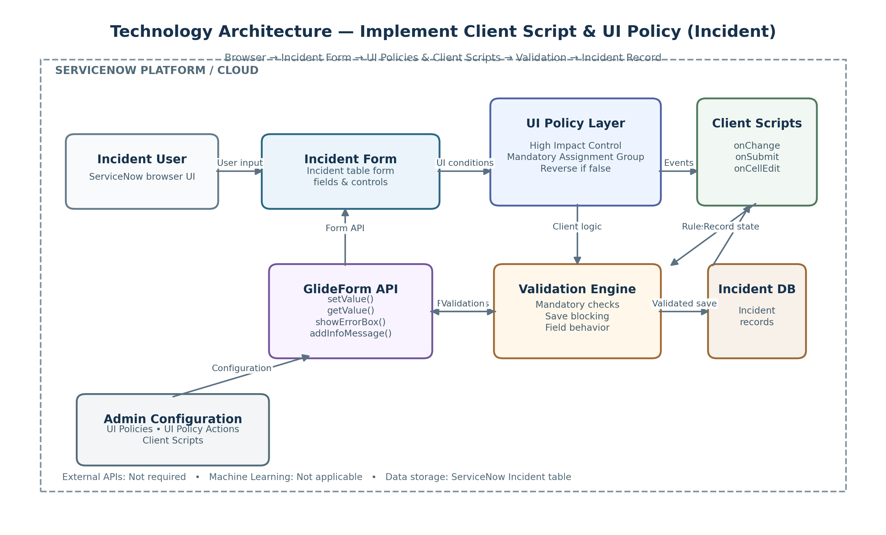
Reference: ServiceNow Incident configuration and project implementation
Guidelines:
Include all the processes (As an application logic / Technology Block)
Provide infrastructural demarcation (Local / Cloud)
Indicate external interfaces (third party API’s etc.)
Indicate Data Storage components / services
Indicate interface to machine learning models (if applicable)


Table-1 : Components & Technologies:

Table-2: Application Characteristics:

References:
https://c4model.com/
https://developer.ibm.com/patterns/online-order-processing-system-during-pandemic/
https://www.ibm.com/cloud/architecture
https://aws.amazon.com/architecture
https://medium.com/the-internal-startup/how-to-draw-useful-technical-architecture-diagrams-2d20c9fda90d

Table-1: Components & Technologies
S.No | Component | Description / Technology
1 | User Interface | ServiceNow Incident form and list interface — ServiceNow Web UI
2 | UI Policy | Controls conditional field behavior — ServiceNow UI Policy
3 | UI Policy Action | Mandatory / read-only / visibility controls — UI Policy Actions
4 | Client Script — onChange | Auto-updates Urgency when Impact changes — JavaScript + GlideForm
5 | Client Script — onSubmit | Validates Assigned To and blocks invalid save — JavaScript + GlideForm
6 | Client Script — onCellEdit | Blocks direct State list editing — JavaScript + callback
7 | Application Logic | Client-side Incident validation and field control — ServiceNow platform
8 | Data Storage | Incident records and configuration metadata — ServiceNow platform database
9 | External API | No external API is required for this implementation
10 | Machine Learning | Not applicable to this project
11 | Infrastructure | ServiceNow hosted platform / instance

Table-2: Application Characteristics
S.No | Characteristic | Project Implementation
1 | Open-Source Frameworks | No separate open-source framework is required; configuration uses native ServiceNow UI Policies and Client Scripts.
2 | Security | Controlled field interaction, validation before save, and restricted direct State list editing.
3 | Scalable Architecture | Lightweight client-side rules are attached to the Incident table and execute only for relevant form/list events.
4 | Availability | Rules are available whenever users access Incident records through the ServiceNow instance.
5 | Performance | Small event-driven scripts perform targeted field checks and updates without external service calls.

Project Reference Notes
ServiceNow Incident table and client-side configuration documented in the project implementation.
UI Policy: High Impact Control with conditional field behavior.
UI Policy Action: Urgency control and mandatory field enforcement.
Client Scripts: onChange, onSubmit, and onCellEdit implementations.
Testing covers mandatory enforcement, successful save, reverse condition, list-edit blocking, and form-based update.

